Service-5-Axis CNC Machining
Demo knowledge file for Content Studio | 5-Axis CNC Machining
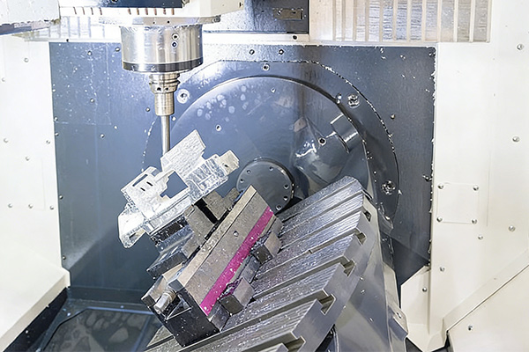
Representative image for 5-Axis CNC Machining service content.

Service Summary
Advanced multi-axis machining for complex geometry, tight tolerance components, and premium hardware applications.
Multi-surface precision machining with 5-axis CNC technology. Perfect for complex, high-tolerance components in aerospace and beyond.

Typical Applications
- Aerospace and UAV structures
- Robotics components
- Medical metal parts
- Complex curved surfaces
- Premium hardware enclosures

Material Coverage
- Aluminum alloy
- Stainless steel
- Titanium alloy
- Tool steel
- Engineering plastics

How Content Studio Should Use This File
- Use this service summary as source material for service pages, blog articles, landing pages, and RFQ-oriented email copy.
- Use the applications list to match service content with buyer scenarios and AI-generated article sections.
- Use the source URL when the generated content needs traceable evidence or a reference link.

Crawled Page Headings
- Service
- 5-Axis CNC Machining
- Find Content
- Explore
- Get In Touch
Source: https://www.rejincnc.com/service/5-axis-cnc-machining/

